**Homework 3**

$(x∧true)→(\left(x∨y\right)∨\left(z↔(x∧y)\right))$

Polish Notation:

$$→(∧\left(x, true\right), ∨\left(∨\left(x,y\right), ↔\left(z, ∧\left(x,y\right)\right)\right))$$

LISP Notation:

$$(→\left(∧x true\right)\left(∨\left(∨x y\right) \left(↔z\left(∧x y\right)\right)\right))$$

1. Function Set = {$∧, ∨, →, ↔$}

Terminal Set = {x, y, z, true}

s-expression:

(→ (∧ x true) (∨ (∨ x y) ↔ (z (∧ x y))))

1. During the evolutionary procedure of standard EA, population will gradually lose diversity when dealing with multi-objective problem. This idea is inspired form real biological evolution. In order to preserve diversity of population, we can use “implicit” or “explicit” approach.

For implicit approach, we can divide whole population into several subpopulations and each subpopulation independently run EA algorithm to produce offspring and fitness selection. This method can avoid feature dominated by specific group. In addition, we can add individual migration mechanism to make communications between subpopulations.

For explicit approach, we can use “crowding” method that attempts to ensure diversity by having offspring replace similar members of the population. After producing offspring, we use some algorithms to calculate the similarity between parents and children. And then make offspring replace similar parent. This method also can preserve diversity of population.

1. First of all, according to the constrains provided, we can plot x-y space diagram as follows:

$x_{1}^{2}+x_{2}^{2}≤10$ $f_{1}\left(\overline{x}\right)= x_{1}=\sqrt{10-x_{2}^{2}}$ $f_{2}\left(\overline{x}\right)=x_{2}^{3}$

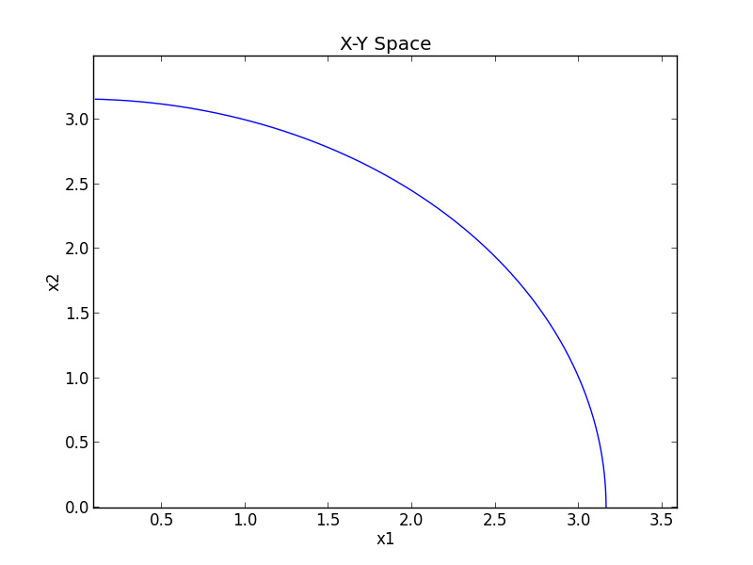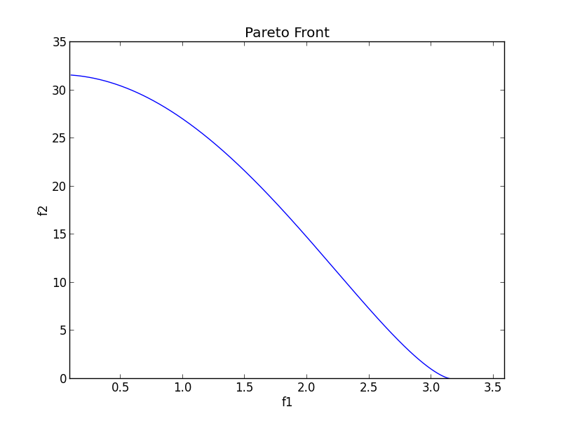

It is like a circle diagram. And then we can map it into f1-f2 space like right-hand side. Blue line is the Pereto front.

1. The performance measure of speed is an evaluation approach to specify when a candidate solution satisfactory and measure the amount of computing needed to achieve this solution quality.

If we use number of generations to establish speed of EA, it will include the information of successful runs and unsuccessful runs for each generation. This will distort our original purpose to find the speed of when a candidate solution satisfactory because for runs finding no solutions will be used as part of measurement. That is to say, if unsuccessful runs are quite large amount, it will not actually reflect the true speed of finding satisfied solution. On the contrary, number of fitness evaluations only focuses on successful runs. Therefore, it is more suitable to represent speed of an EA.

1. Genetic Programming

In this code, I use Symbolic Regression test example to demonstrate the “bloat.” In this test, I choose total individuals = 800 and generations = 180. And we have to make mean square error as minimize as possible, so this can be seen as performance index for each generation.

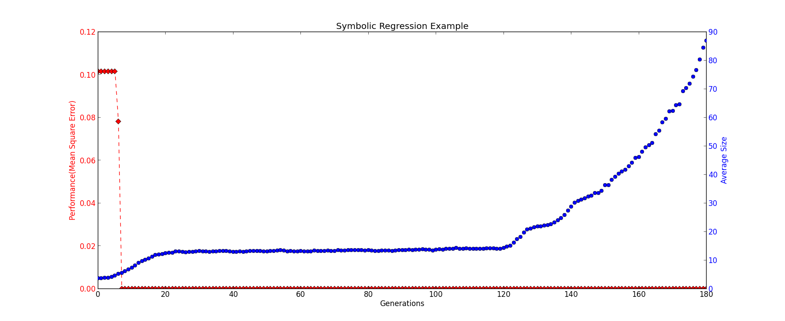

Mean square error immediately shrinks to very small value in the beginning generations. At the same time (the position of arrow point to), individual’s size starts to bloat. In the final generation, size grows even much larger. This phenomenon doesn’t obviously affect performance, but has extremely computation overhead of our computer.